From the ATA Archives: "Recycled" Snowshoe Bindings
by Tom Paragi

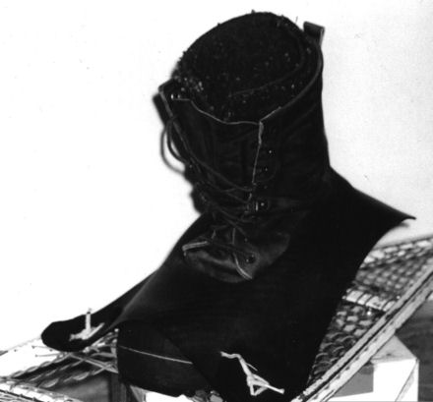
When I was about age 10, my neighbor let me borrow an old pair of long, skinny snowshoes so I could learn to navigate the woods and fields of upstate New York in winter. The bindings he had made were simple affairs of inner-tube rubber from truck tires. Over the years I have used several different types of bindings on various snowshoe designs, but for general use I have gone back to the rubber bindings.

The photos show the bindings for a size 12 boot. Get a heavy duty inner tube from a tractor trailer tire if possible; most commercial tire shops have old ones for free. The outer shape of the binding is not important, but the location and size of the boot slot is. Start small and carve at the sides and heel until your boot just scrapes through after some effort. The smallest knife cut or nick at a corner will tear out with use, so I use heavy scissors or shears once I have started the cut with a knife.

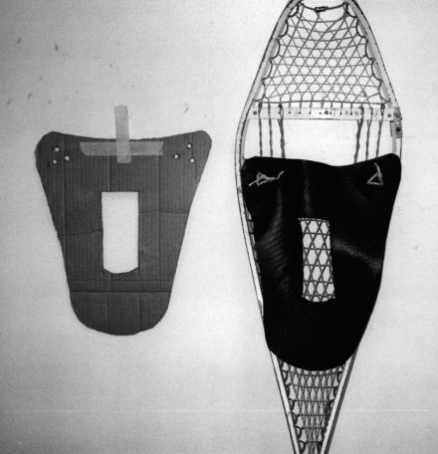
A 1/4 inch arch punch is ideal for putting 3 to 4 holes at the two sides where the binding is lashed to the master cord of the snowshoe with parachute cord. If you look closely at the photos you can see the 3 inch rubber disks that go over the attachment point and have the same hole pattern as the binding. They reinforce the attachment point and reduce tearing of the holes.

Depending on the size and style of your boot, you may have to experiment with how tight to make the toe strap part of the binding. If it's too loose, your boot will be sliding forward too far into the toe hole of the snowshoe. Having it too tight will put extra strain on the holes at the attachment point, leading to a shorter life for the rubber.

I especially like these bindings if I slog into overflow. Unfastening a leather buckle or rope binding when it has become a ball of ice is no fun, especially with frozen fingers. The rubber bindings remain surprisingly pliable in the cold.

If you take a tumble in deep snow with these rubber bindings, your boot will pop out of the toe hold (but the snowshoe will still be attached around your boot). This is actually a safety release, similar to bindings on modern skis, that gives way instead of your poor ankle or knee.
Many years ago I read sound advice about snowshoe bindings from Johnny Thorpe, a professional trapper from the Adirondack Mountains of New York. He recommended unhooking your heels from snowshoe bindings whenever crossing a river or working near a beaver lodge, where ice could be rotten. The toe hold alone will keep the snowshoes on your feet as long as you walk forward, yet the shoe will pop off with a twist of your foot if you go through the ice. Having ice picks (with loosely-fitting point covers) in your parka pockets and a partner to help are also good ideas when crossing questionable ice.

The only terrain where I have found the rubber bindings to be too flexible is steep pitches on hard-packed snow. The Sherpa-style snowshoes with foot cleats and solid bindings are much better in the mountains, where overflow is often confined to narrow creeks and usually avoidable.

Alaska Trapper, September 2003

(Clipped from: http://www.alaskatrappers.org/stories_recycled_snowshoe_bindings.html)

NOTE: While it is possible to construct your own pattern by cutting and shaving as Mr. Paragi indicates, I found a PDF file which works for a variety of boot sizes from size 10 youth to size 13 mens. (see the file “Inner_tube_snowshoe_binding-1.pdf”). I have used these successfully in retrofitting our groups snowshoes at little cost other than some time and effort.

I find with the Cubs that this type of harness is easier to use than the traditional lampwick/webbing harness and it is considerably less expensive than purchasing the modern nylon harnesses with the plastic quick release buckles.

As for a source of truck inner tubes, I found that our local tire shop was glad to give us as many old truck tire inner tubes as we needed. They have a large bin of bad tubes in the back that they have thrown out and as long as we asked politely they would put a bunch aside for us.

Scouter “Kaa” (Bruce Blacklock)
116th Lynnwood Cub Pack

