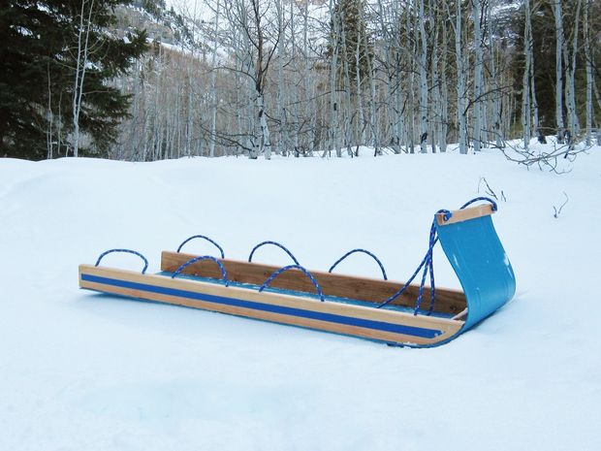
Perhaps you're like me, and have always dreamed of making a traditional bent-wood toboggan. However, like me, you realize that doing so requires a lot of time and tools you may not have. So I was thinking . . .
How can I easily make a toboggan that's both fast to make, and FAST on the slopes?
Ideas began to formulate in my wee brain for a non-traditional toboggan, and after some time in the shop here is the finished result!
This is a wicked-fast toboggan, made simply from the following items:
- 55-gallon plastic barrel
- two-by-fours
- handful of screws
- rope
- wax!

This is pretty straight-forward, and only requires a few basic tools. Make sure you've got some affordable health care and . . .
Let's go tobogganing!

Step 1: Materials
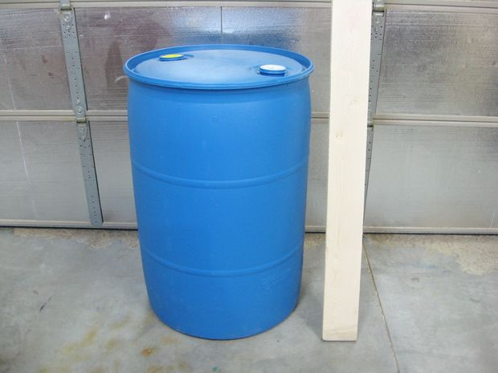
I picked up a used plastic barrel through my local classifieds for $10. It originally held some kind of detergent. Large car wash facilities are a great source for clean-ish barrels like this, for use in diy projects.
I originally planned on using maple wood for the side boards (as shown), but this lumber got appropriated for a different project. So I went with 2x4s instead, which worked out better anyway.

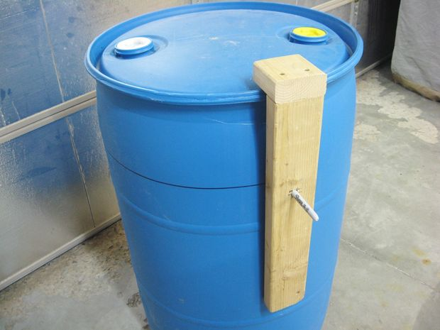
Step 2: Measure and mark barrel
There is an existing vertical seam on the barrel, which I traced with a marker to make it easier to see when cutting. The barrel is almost exactly 72 inches around.
The runner for the toboggan is made from the side section of the plastic barrel, which will be cut out with a jigsaw.
I rigged up a simple marking device with some wood scrap and a marker.
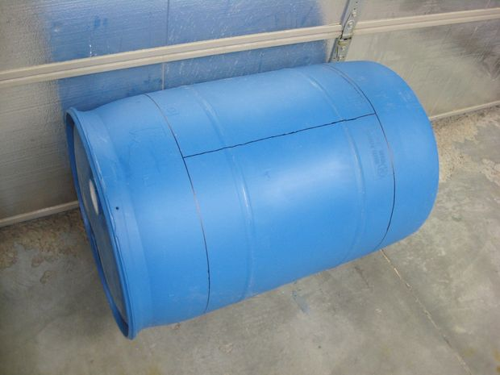
The runner I made is 22 inches across, so I marked the barrel accordingly from both the top and bottom so the raised ridges on the barrel sides were lined up symmetrically on the piece I was going to cut out. See photo notes for additional details on marking the barrel.

Step 3: Cut out runner from barrel
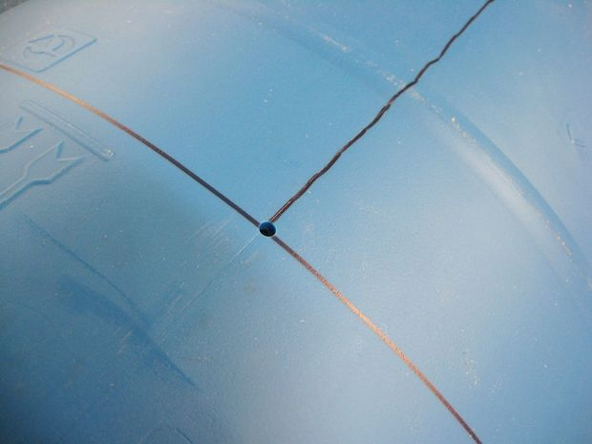
To cut up the barrel, I only recommend using a jigsaw. It is the safest, easiest, and quickest way to do this.
First, drill a 1/4" (or so) hole at the top and bottom of the vertical line. Then carefully trim off the top and bottom of the barrel.
Then cut through the vertical line.
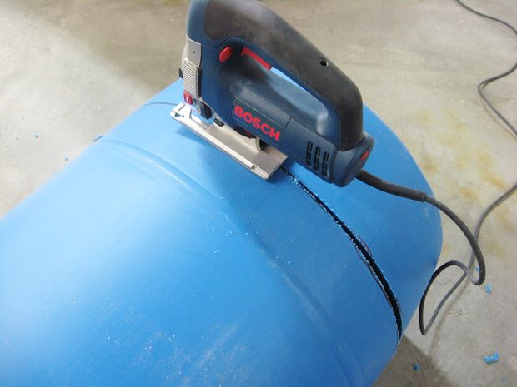
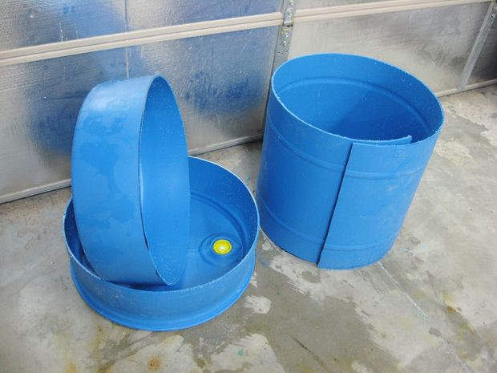
Step 4: Flatten the runner
I put a lot of thought into how to best to use this middle section of the barrel as a toboggan runner.
What I ultimately concluded was that the perfectly smooth inside of the barrel is the part we want in contact the ground. There are bumpy letters and other markings on the outside that we don't want dragging in the snow.
Also, by doing it this way, we take advantage of the slight top-to-bottom vertical curve of the barrel. Putting the inside down creates edges of the runner that curve down ever-so-slightly, and act as sharp guiding edges (kind of like on skis and snowboards).
. . . So we need to flatten this curly middle section of the barrel as much as possible.
The easiest way to do this is to roll it tightly in reverse by hand a bit at a time, to break the "memory" and flex the material until it rests in a mostly flat position. This requires a bit of muscle and elbow grease, but it's not to hard to do.
It may also be helpful after the runner has been worked manually, to just roll it up tightly in reverse and duct tape it together while you work on the other parts. That's what I did.

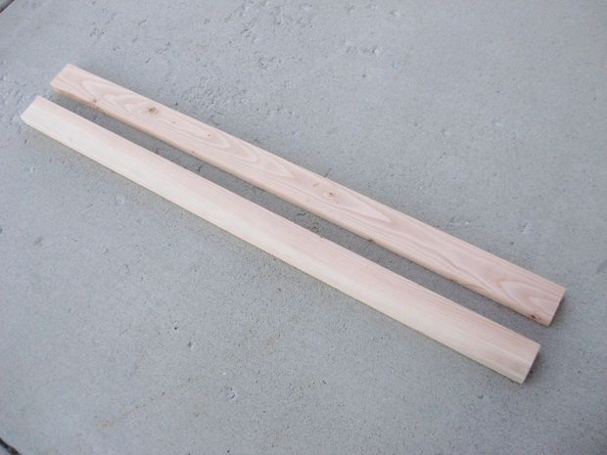
Step 5: Wood pieces
About 3/4 by 1 1/2 inches, and 22 inches long.
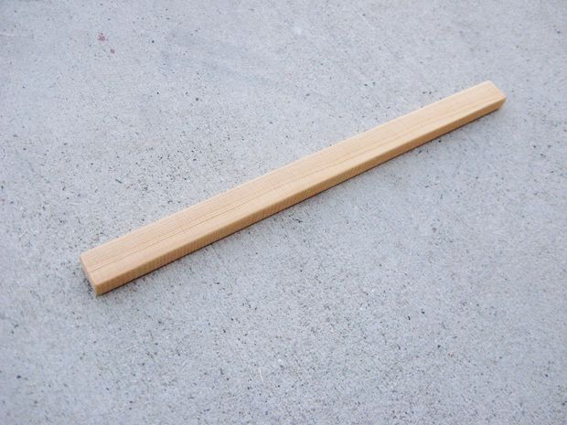
There are two wooden braces that run the length of the toboggan, made from 60-inch pieces of 2x4. Any timber will work, as long as it is wide enough to bore holes out on the bottom side to hold the knotted ends of whatever rope you use (see later steps for details on this).
There is also a front "handle" piece of wood that goes onto the front of the toboggan (shown in photo 2), and an additional piece of 2x4 that will be installed as a brace between the front tips of the side boards (shown later on).
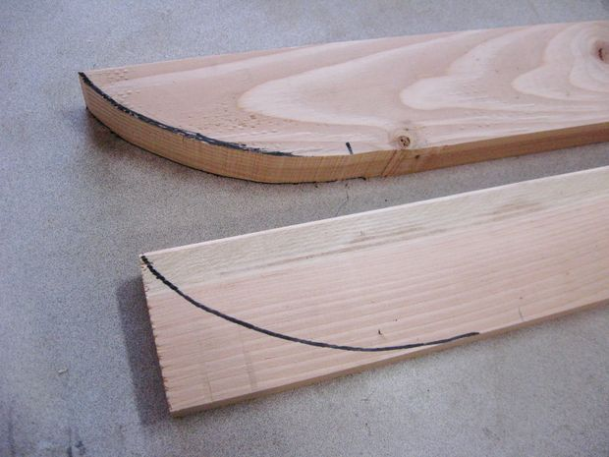
Step 6: Prepare tips of side boards
The side boards have a slight curve cut into the front end.
See note in photo one for dimensions where to mark and cut. These cuts can be done easily with either a band saw or a jigsaw.
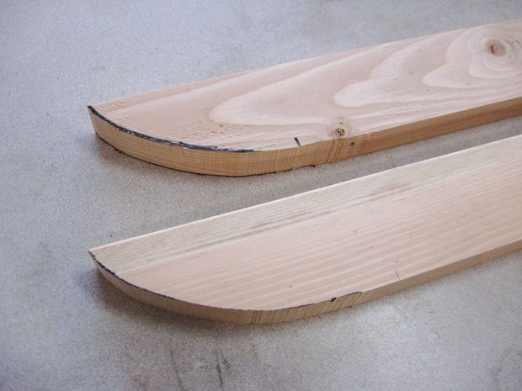
Step 7: Layout marks for rope handle holes
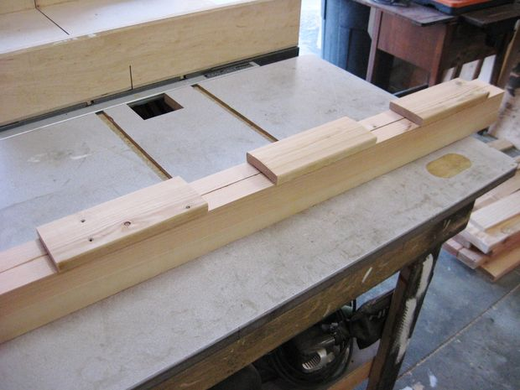
I cut three 9-inch boards to act as spacing guides to help me visualize an ideal layout.
Five inch gap.
Five inch gap.
Three inches from the back.
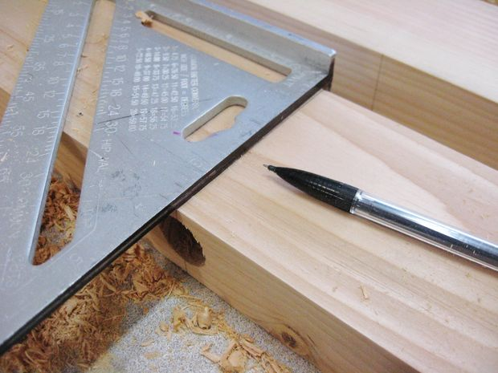
A line was marked with a pencil at the top and bottom of each of these boards.

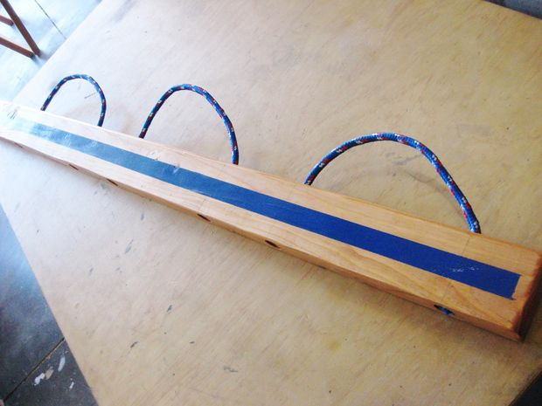
I put three handles on each side made with rope that were threaded in place through bored out holes in the side boards, and held in place with captive knots. Each handle is made from an individual section of rope.
If you would like to duplicate my layout for handles, see notes in photo two for measurements and tips on spacing.

Step 8: Bore holes for rope
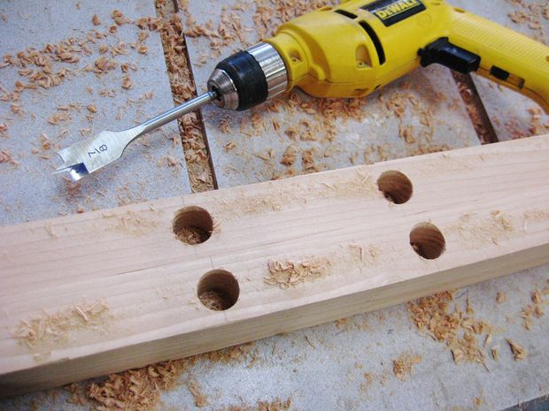
From the bottom sides of the boards, I bored out holes that were 7/8" wide and about 1" deep to hold the knots. (I used 3/8" rope.)
The center line of these holes were transferred to the sides and then to the top with a framing square. Then the holes were bored from the top side with a 1/2" bit down to meet up with the larger bore.
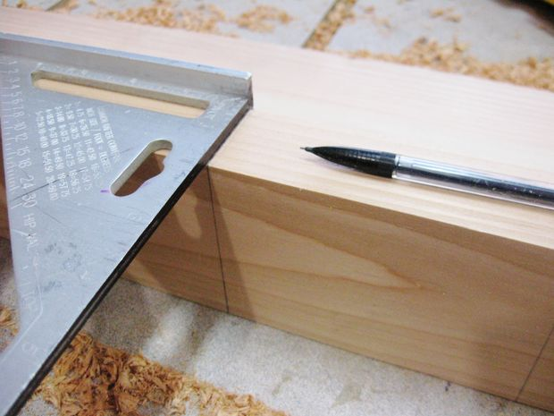

Not shown here, but important:Bore holes in the same fashion through the front of each side board at the six-inch mark. Rope will be attached through these holes to hold the front part of the toboggan in place, and also act as the tow-rope.
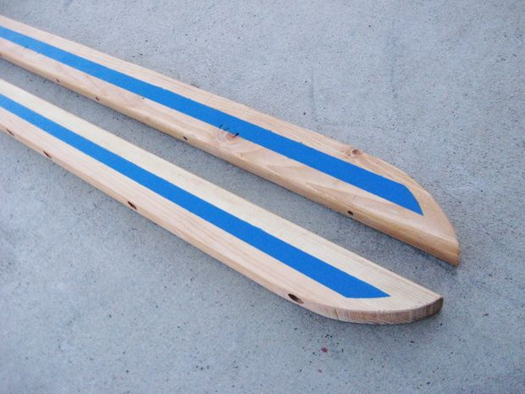
Step 9: Finish all wood pieces
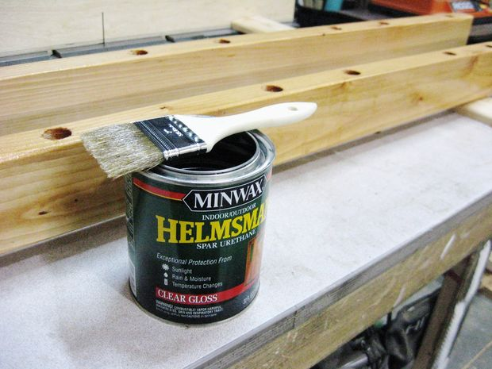
If you want this to last a long time, I recommend finishing all the wood pieces with several coats of spar urethane, according to the directions on the can.
Be sure to sand between each coat lightly with 220 grit sandpaper so you end up with a very smooth finish.

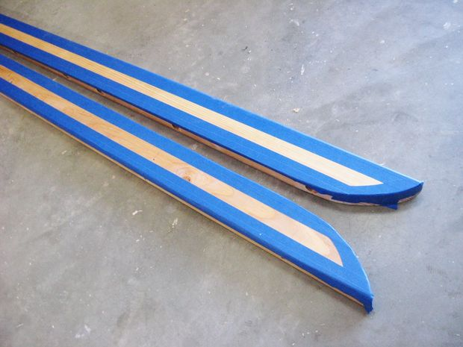
Step 10: Optional: Add racing stripes!
After adding my final coat of spar urethane, I decided to add some blue racing stripes.
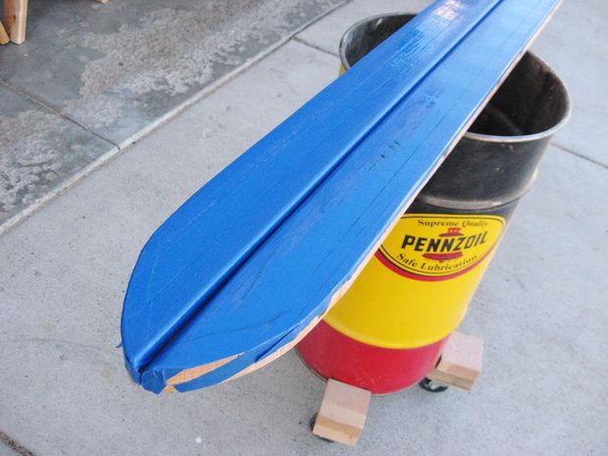
I used tape to mask off where I wanted the stripes to be, and then sprayed on a coat of clear lacquer first. This seals the edges of the tape, so any "bleed-under" from this first coat is actually clear. This ensures that additional coats leave a crisp and clean-looking paint line.
I then sprayed on a few coats of blue spray paint, and removed the tape. Racing stripes!
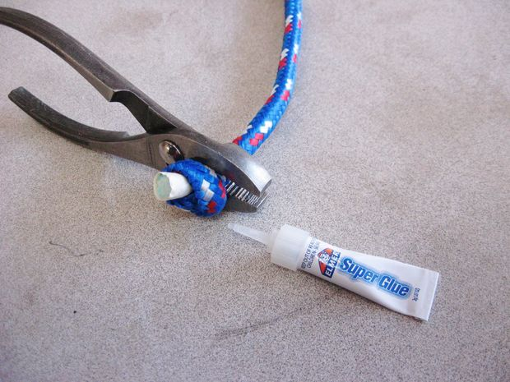
Step 11: Cut rope sections for handles and towrope
Place a pair of pliers lightly over rope. Grip the pliers over the jaws and use them to pull against the knot to tighten it. This will make a very tight knot.
Squirt some super glue onto the knot to keep it from unraveling at some future date. Not likely to do so, but a little super glue insurance can't hurt.
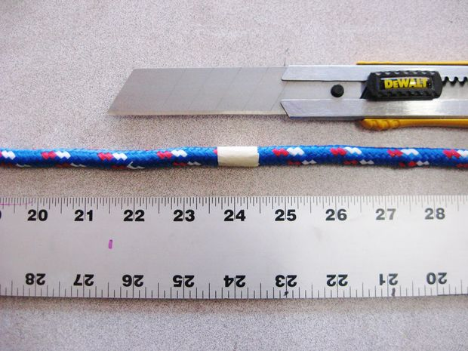
Each section of rope used for a handle was 24 inches long. The quickest way to "fuse" the ends of the rope in this case is to simply wrap the area you are going to cut with masking tape. Then cut through the middle of the tape with a utility knife, and both ends are done. Easy peasy!
For the tow rope I cut two 5-foot sections of rope with the ends finished in the same manner.
For all sections of rope, I tied a knot in one end to prepare them for installation into the boards. See photo 2 for some tips on this.
Step 12: Install rope handles and tow ropes
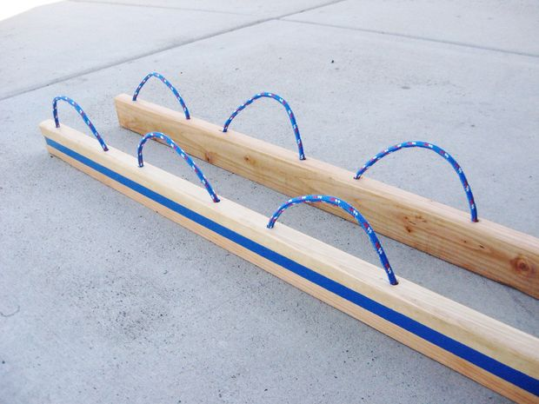
The rope handles and tow ropes are installed now.
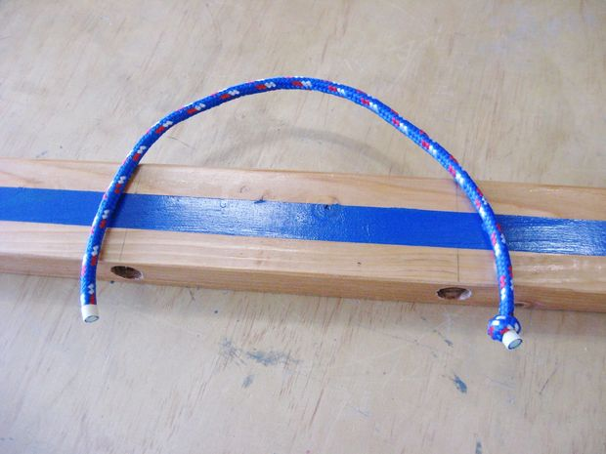
Thread each handle up from the bottom and down the proper hole. Tie a tight knot and glue if desired, and pull the handle back up tightly to seat the knot in the bottom hole.
Do likewise for the front tow ropes.
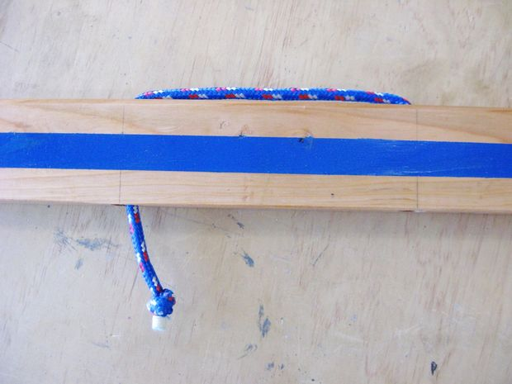
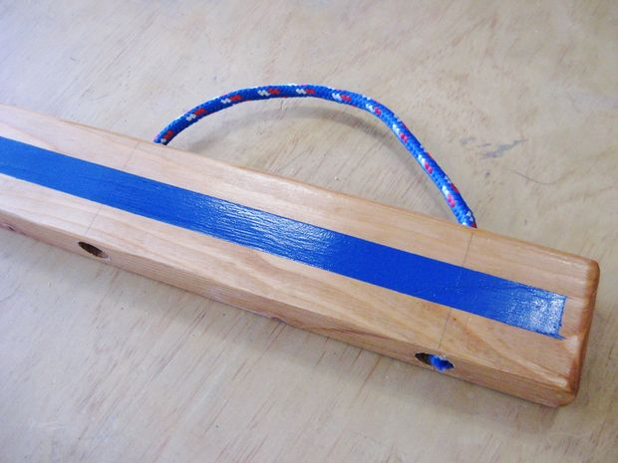
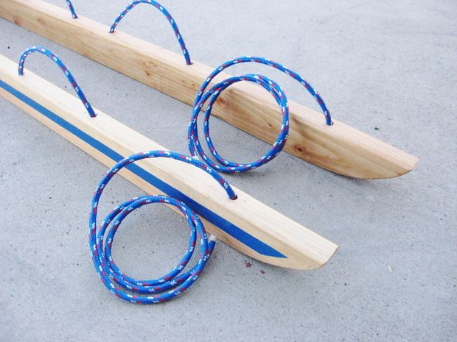
Step 13: Attach front edge board
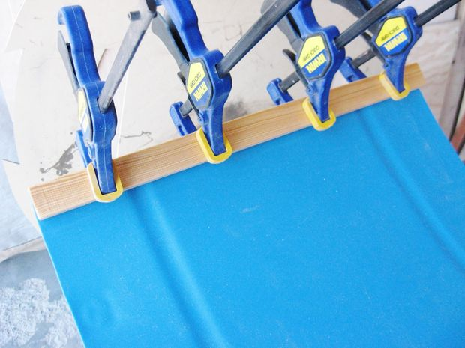
The little board that goes at the front of the sled serves a couple purposes. It acts as a handle when riding, but also as a stiffener and support for the tow rope.
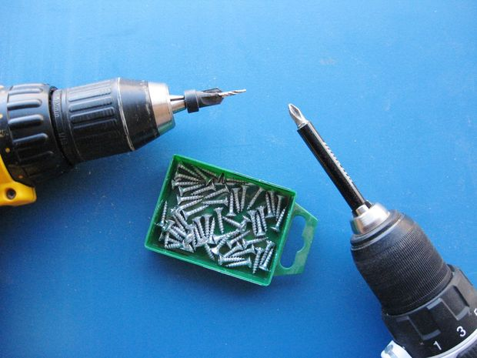
I clamped this in place at one end of the runner, onto the smooth down-side. I attached this to the runner with several 5/8" screws into predrilled and countersunk holes.
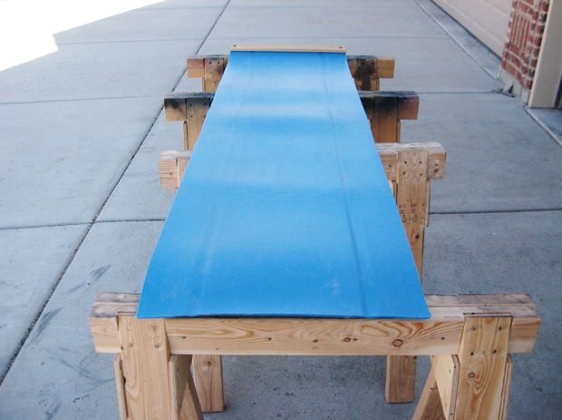
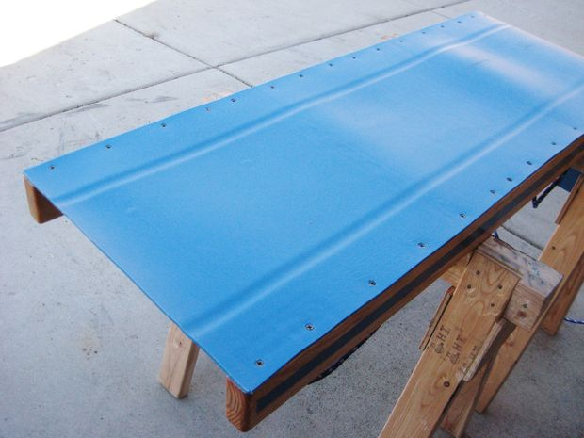
Step 14: Attach side boards to runner
The side boards are attached to the plastic runner with screws installed from the bottom side.
It will help if you have a couple of nice sawhorses to place your almost-finished toboggan on while you work on it.
I used some 2" screws that were salvaged from some old thing I took apart years ago. I'm not even sure what it was, but these screws had a nice big head on them.
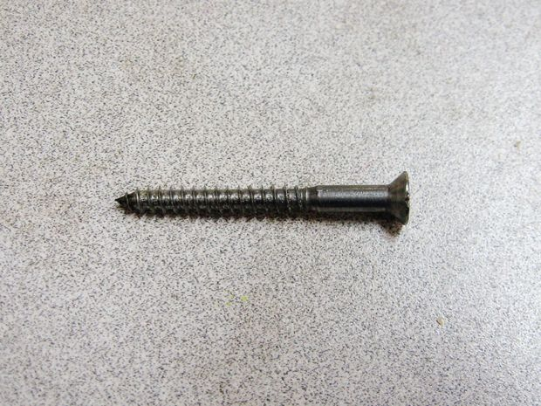
If you're making this and looking for screws to buy, I recommend looking for something similar to the one shown in photo 3.
The trick with this step is to clamp the runner in place to the boards, and predrill and countersink your holes.
I worked from back to front, one board at a time, and clamped right next to where I was putting a screw and moved the clamp forward as I worked. Make sure you avoid putting any screws in too close (or right on top of) the holes that are holding the ropes!
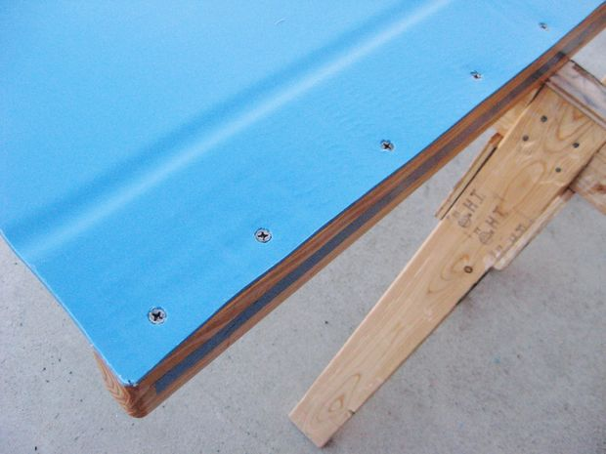

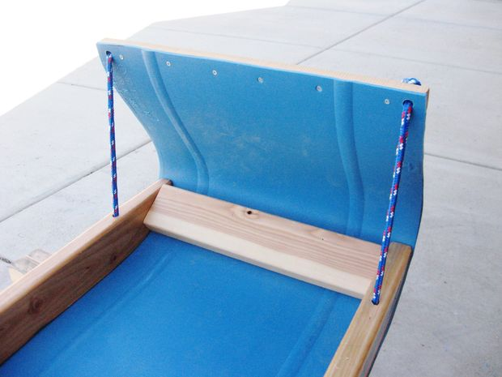
Step 15: Add front brace
A front brace made from a piece of 2x4 was added between the front tips of the side boards. This was screwed in place through the side boards and also from the front side through the plastic runner.

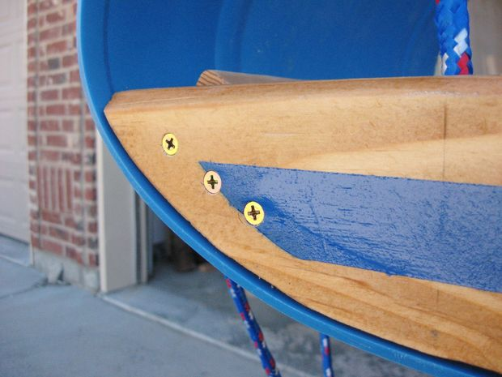
This was actually a late addition, but was greatly needed. It keeps the side boards from splaying out, and really solidifies this curved (and most-stressed) section of the toboggan.
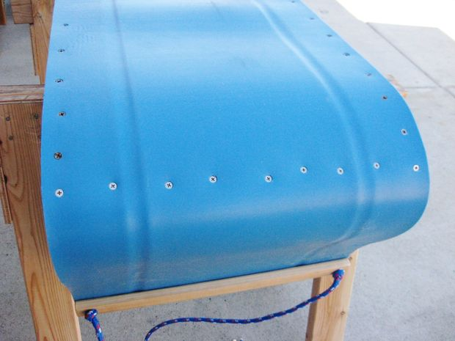

Step 16: Install tow ropes through front board
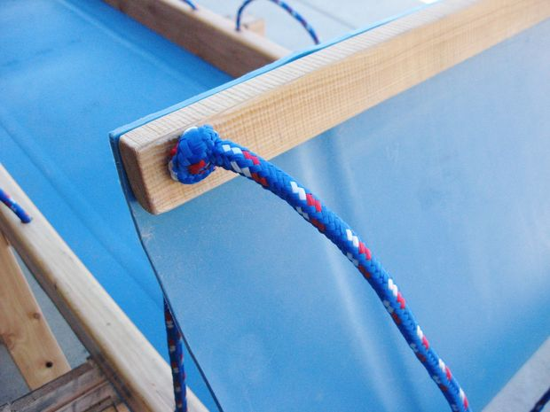
Carefully drill a 1/2" hole through each side of the board at the front of the toboggan.
The two ropes that make the tow rope are installed through these holes, and the front end of the toboggan is pulled up and curved to your liking and held in place by knots tied in these two ropes. The two loose ends are then tied together.
You're almost done!

