http://www.wilderness-survival.net/forums/showthread.php?13921-What-Kind-of-Snow-Sled/page2

The photographs were clipped from the web site above and the person who posted them was
from Vaasa, Finland, so I suspect that he might have a reasonable working knowledge of pulks.

"You could always DIY from pine and 4mm plywood" (roughly 1/8" plywood)

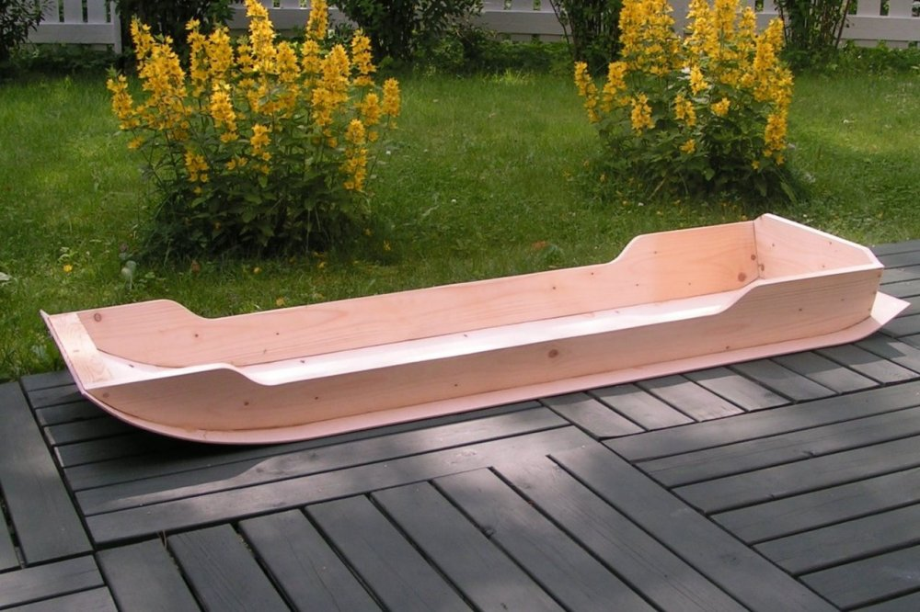

I suspect if you built one of these of ¼” plywood and clear grained pine, you could improve the durability by applying either a coat of epoxy or a layer of glass and epoxy to make it tougher.

Note that the sides are not at 90 degrees to the bottom but are tapered outward slightly to allow the pulk to ride better in the snow.

Note in the final picture that the pulling connection seems to be leather and harness hardware.

Perhaps weekends project for the Scouts as part of their winter camping requirements.
